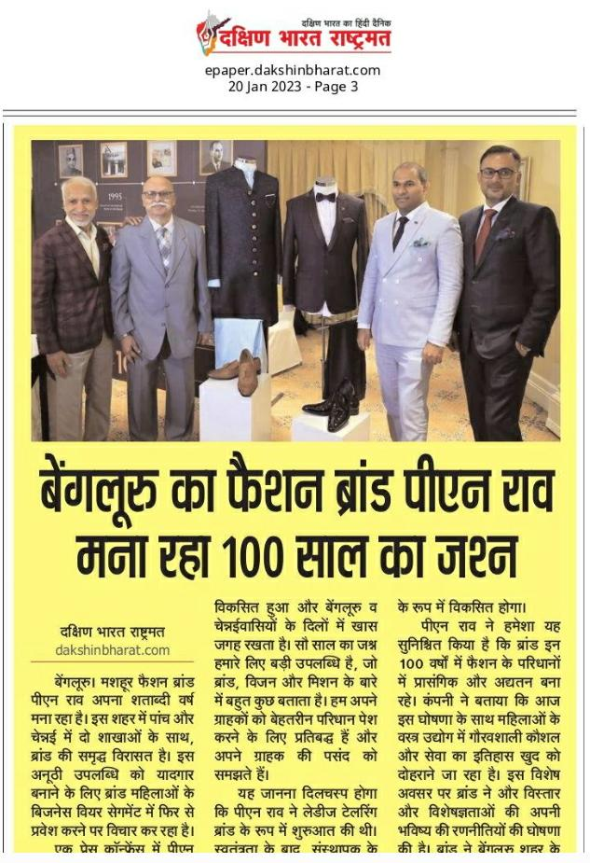

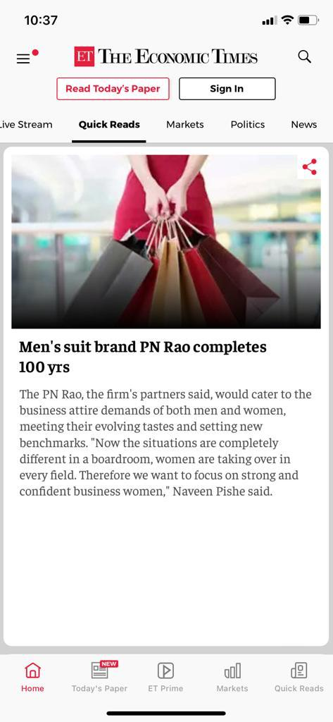

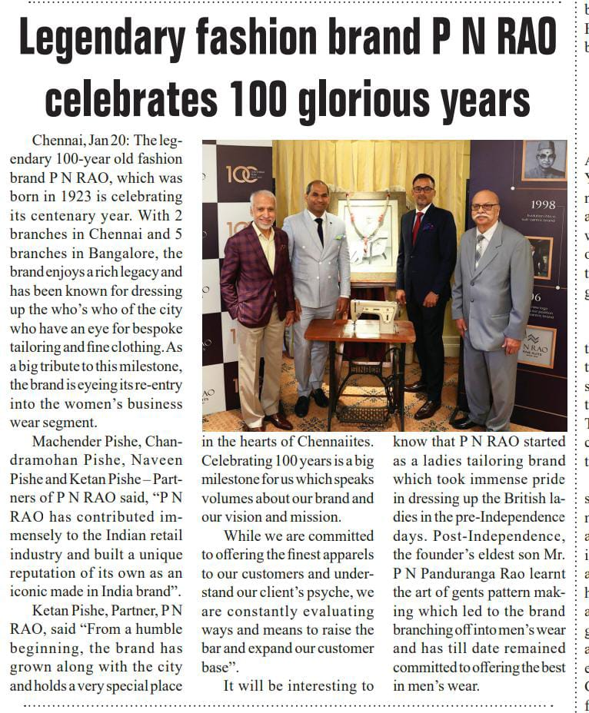

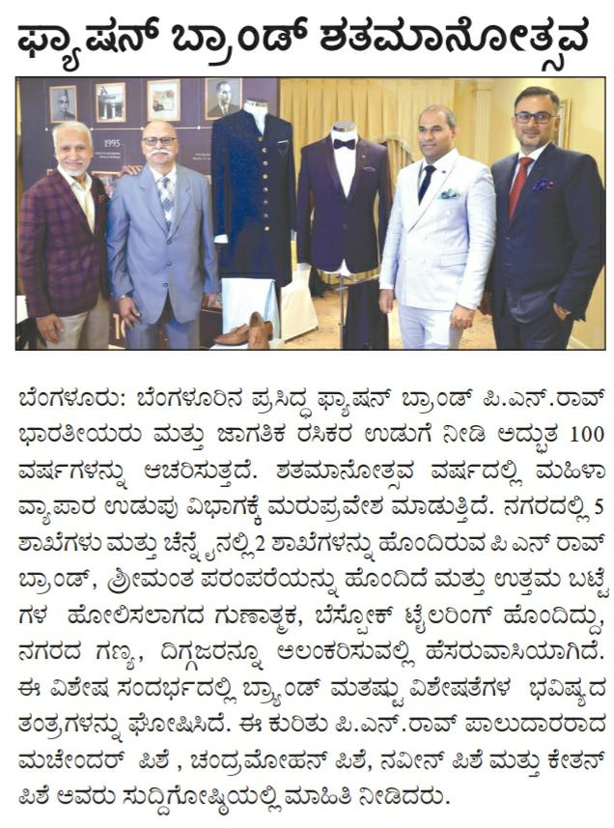



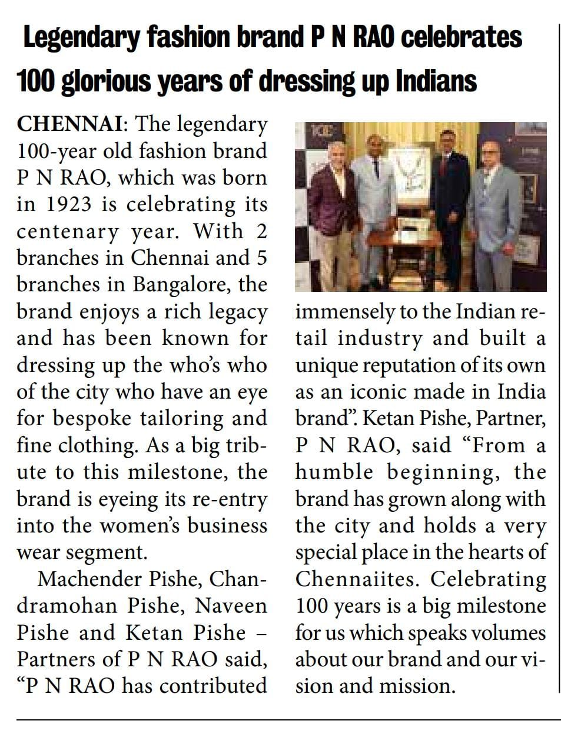

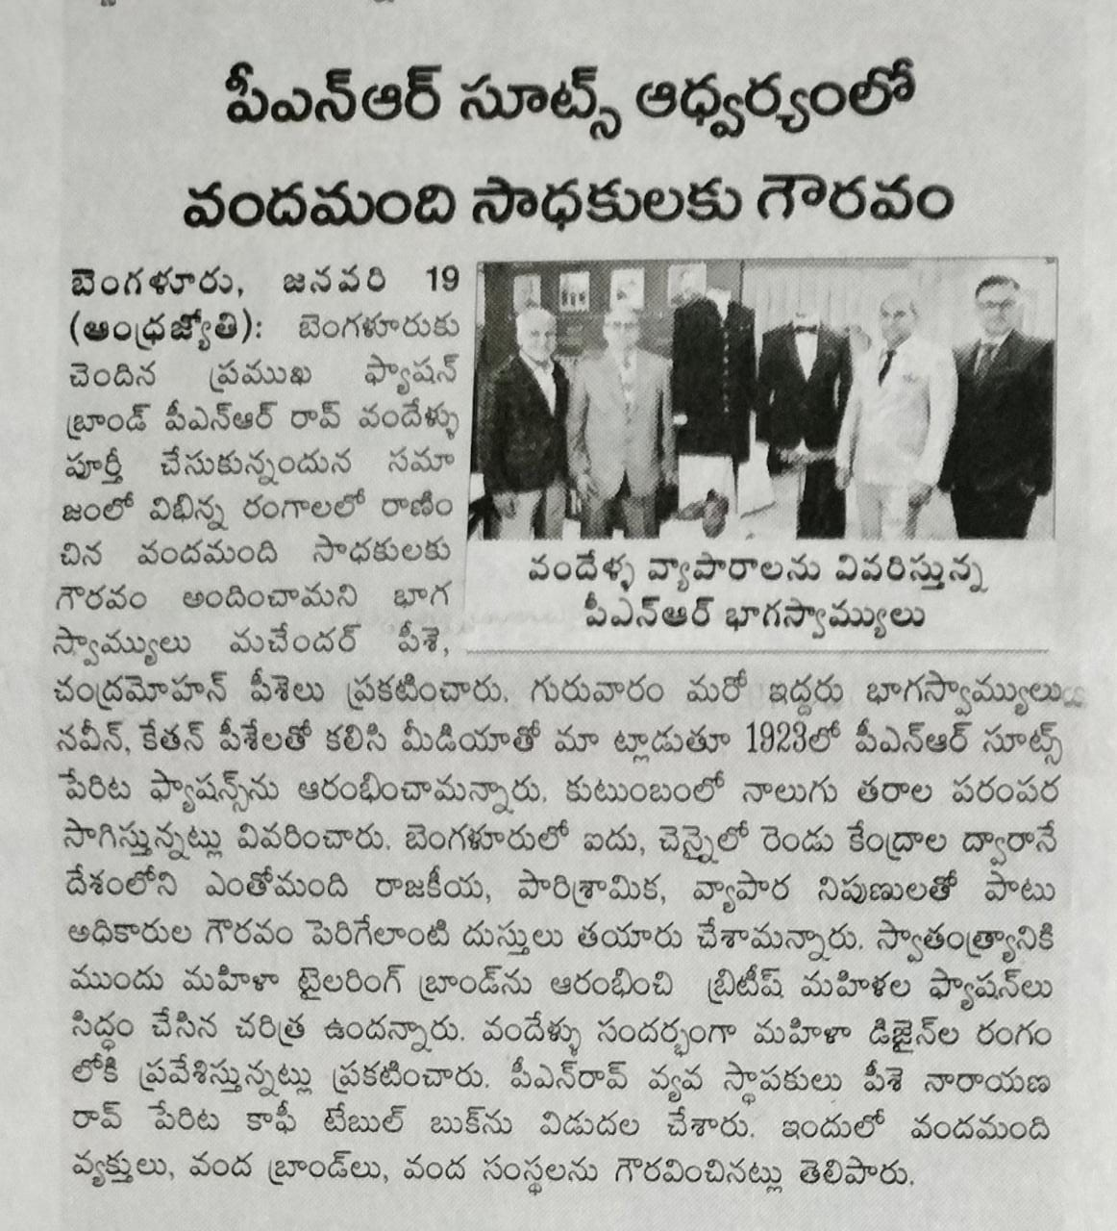

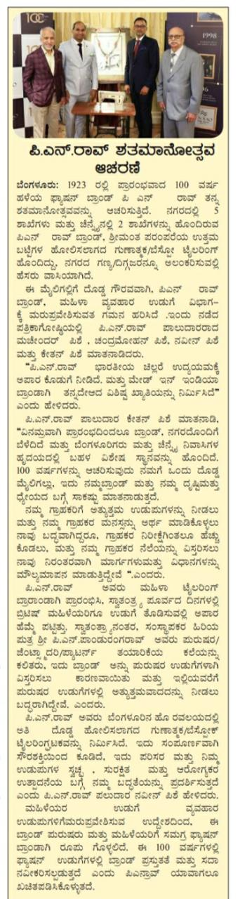

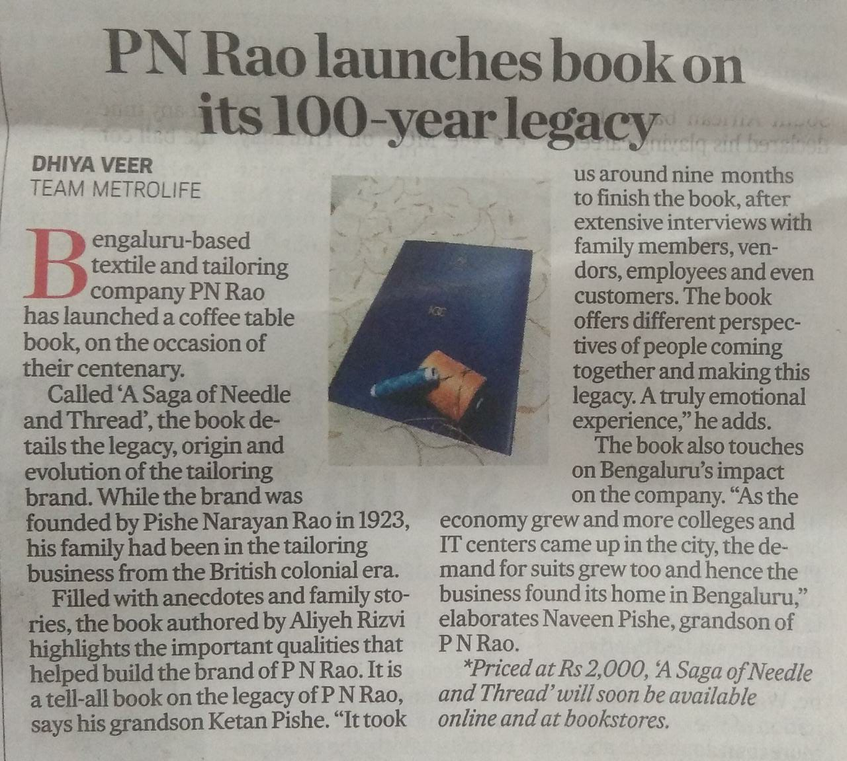



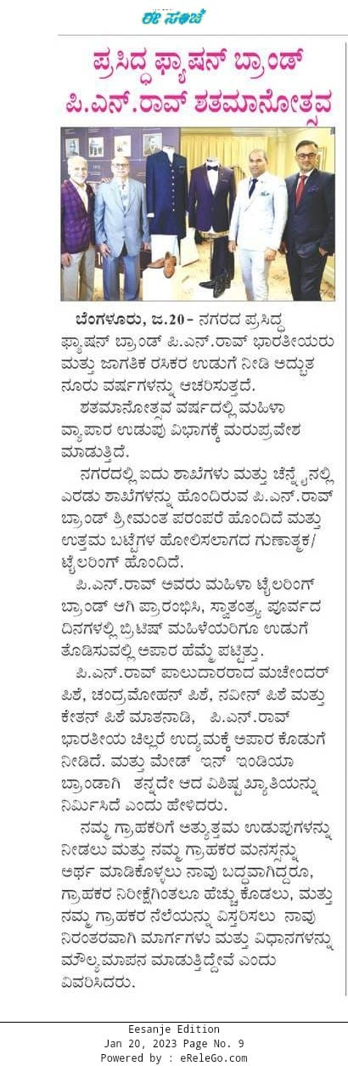

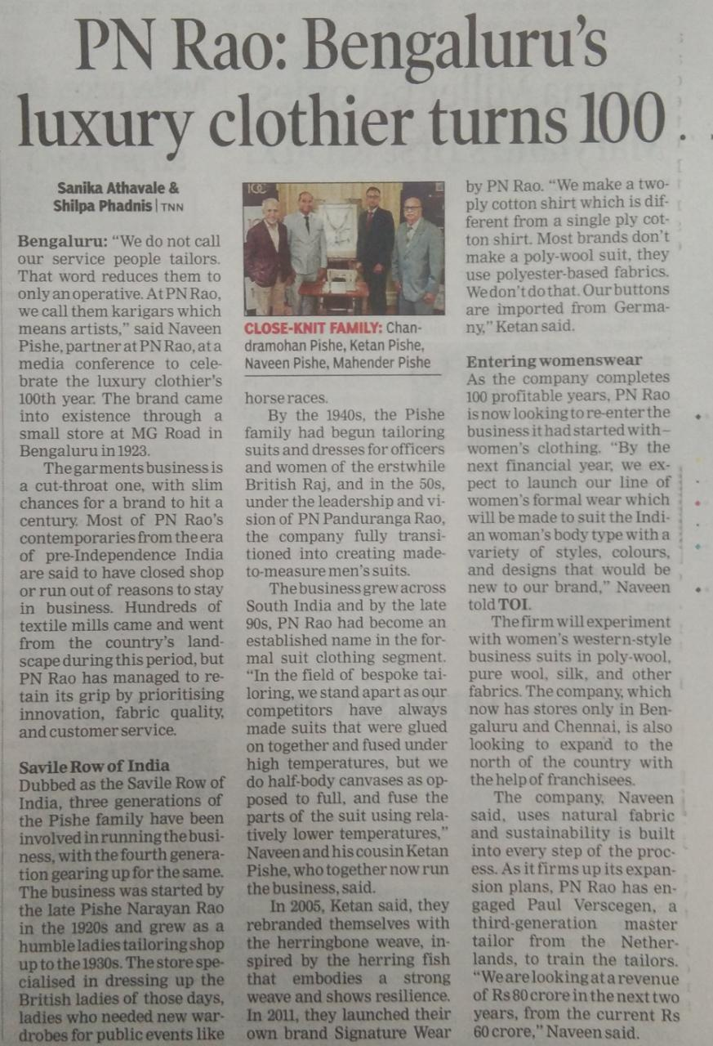

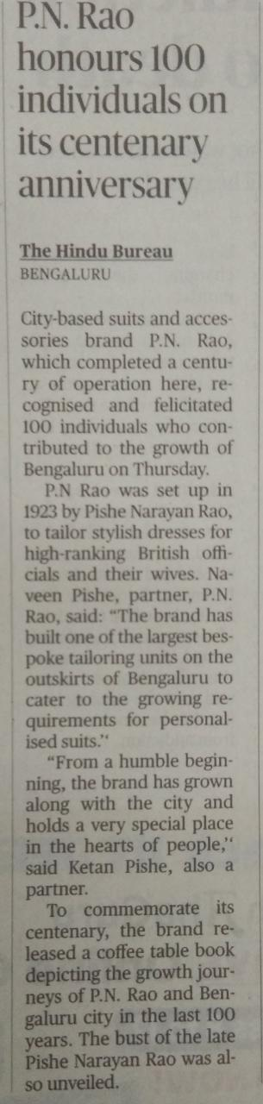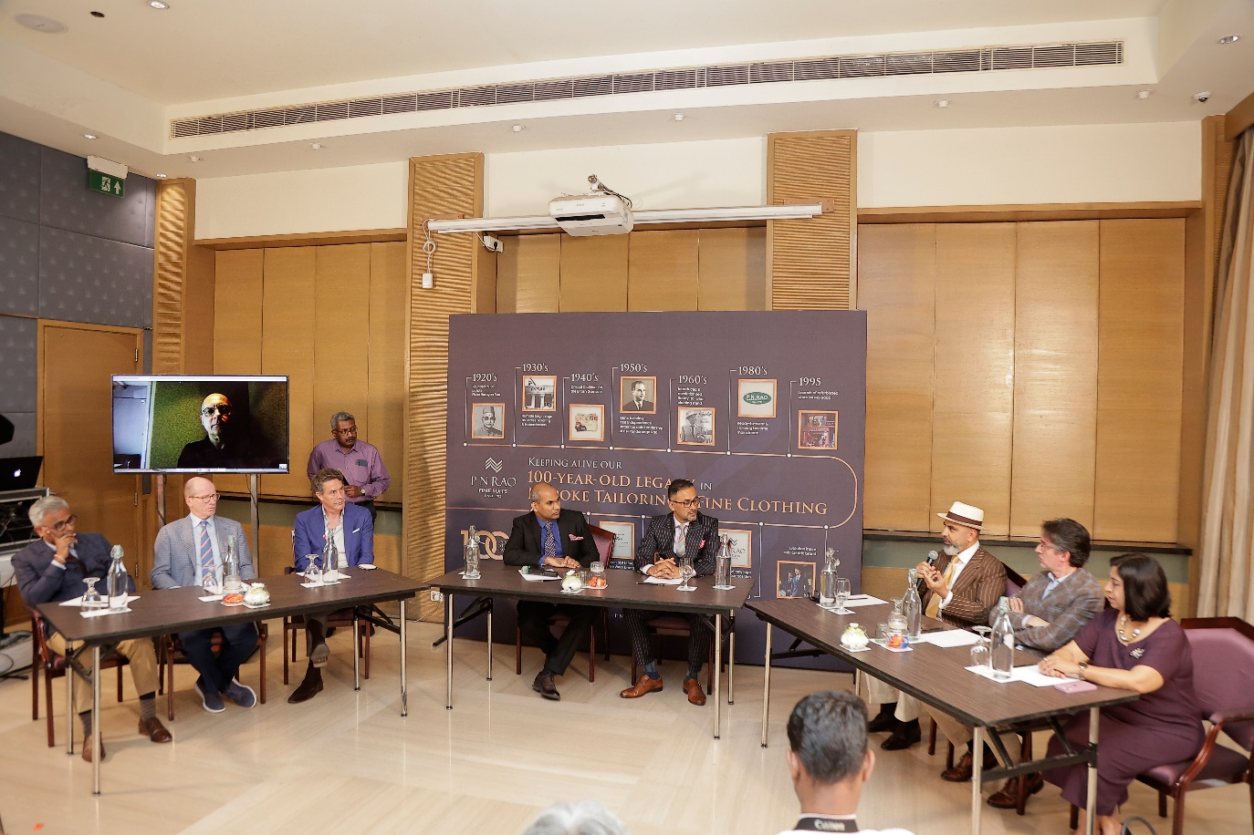

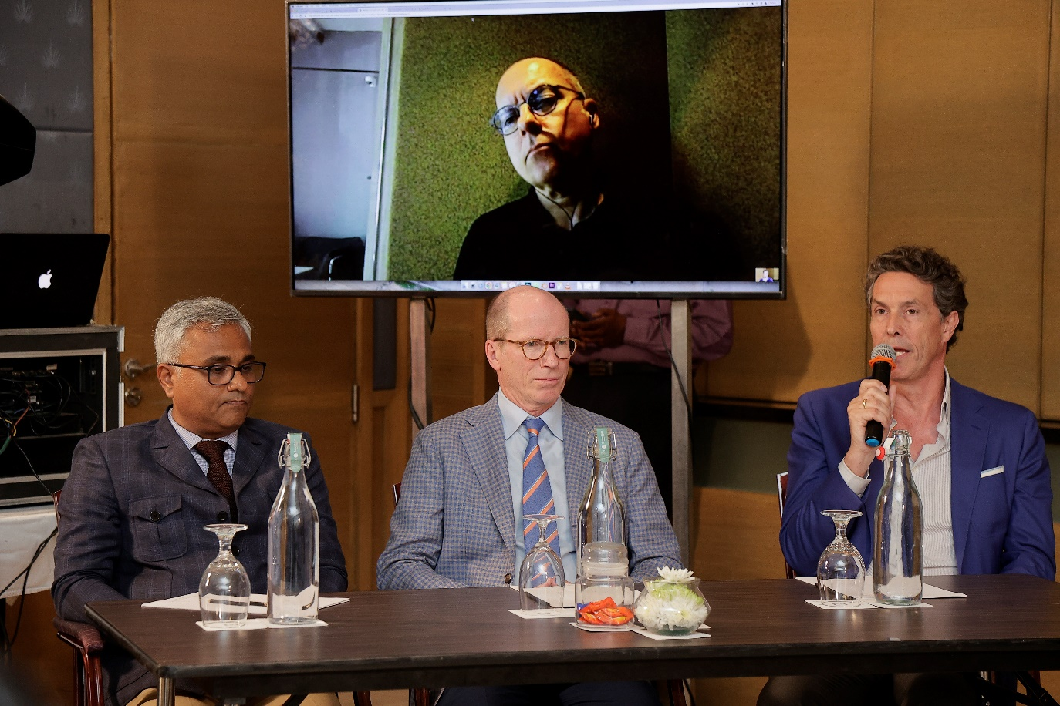





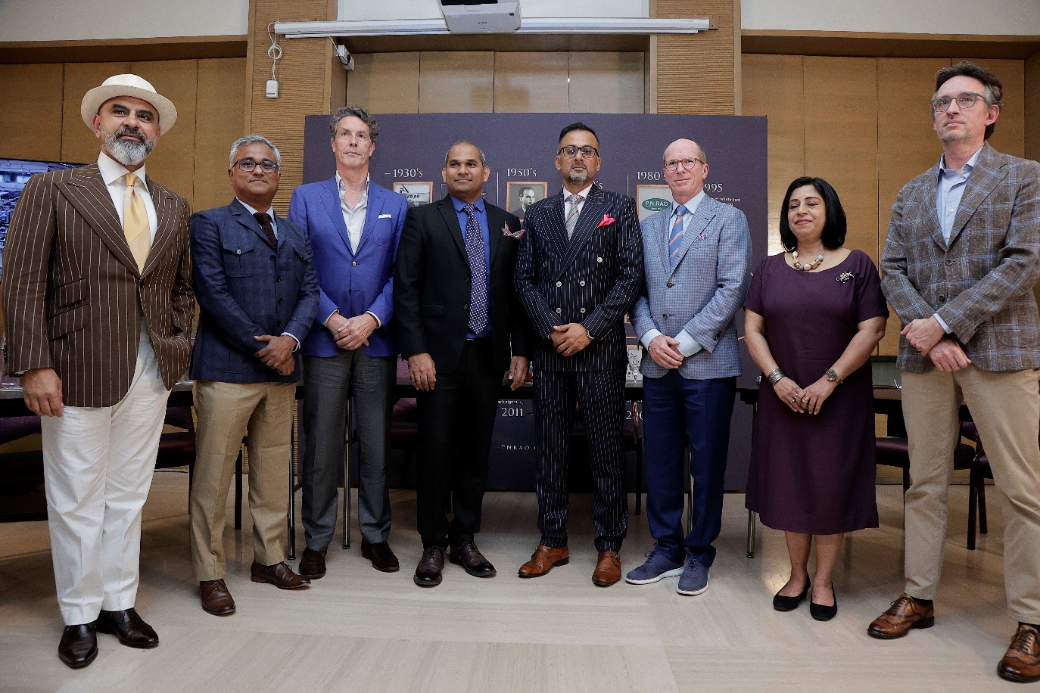

<https://www.thehindu.com/features/metroplus/fashion/pn-rao-plans-to-foray-into-power-suits-for-the-ladies/article66895650.ece>

<https://www.apnnews.com/celebrating-their-cenetennial-year-p-n-rao-brings-global-industry-leaders-to-talk-about-paradigm-shift-taking-place-in-luxury-fabrics-and-bespoke-tailoring-in-india/>

<https://www.prittleprattlenews.com/business/celebrating-its-centennial-year-p-n-rao-brings-global-industry-leaders-to-talk-about-the-paradigm-shift-taking-place-in-luxury-fabrics-and-bespoke-tailoring-in-india/>

<https://www.indiaretailing.com/2023/05/26/mens-suit-maker-p-n-rao-celebrates-centennial-year/>

<https://www.youtube.com/watch?v=y63iWmD_N90>

<https://www.youtube.com/watch?v=Ffdlq4ynj3E>